CSA6303 - THREAT INTELLIGENCE AND NETWORK SECUR
Assessment Tool 1: CONCEPT MAPPING
Faculty : Dr.V.Parthipan SLOT A
Topics: Network Security Fundamentals | Security Goals (CIA Triad) | Types of Network Threats
|Introduction to Threat Intelligence Types of Threat Intelligence (Strategic, Tactical, perational) — Threat Intelligence Lifecycle — Applications in IT Industry
CO1: Interpret security principles, network threats, and the role of threat intelligence in cybersecurity.
Total: 50
Student Name :K Avinash Reddy Register number: 192312463
Code of Conduct:
I K Avinash Reddy(192312463) (Name / Reg No) certify that this submission is my original work and that I have adhered to the guidelines specified for this assessment. I understand that any violation of academic integrity rules will result in disciplinary action.
Signature of the student: Avinash Reddy

CO1:CONCEPT MAPPING:

3. Construct a concept map classifying different types of Network Threats and their
potential impact on security goals. Connect threats such as malware, phishing, denial-of-
service, spoofing, eavesdropping, and unauthorized access with the CIA Triad and explain
the resulting security implications.

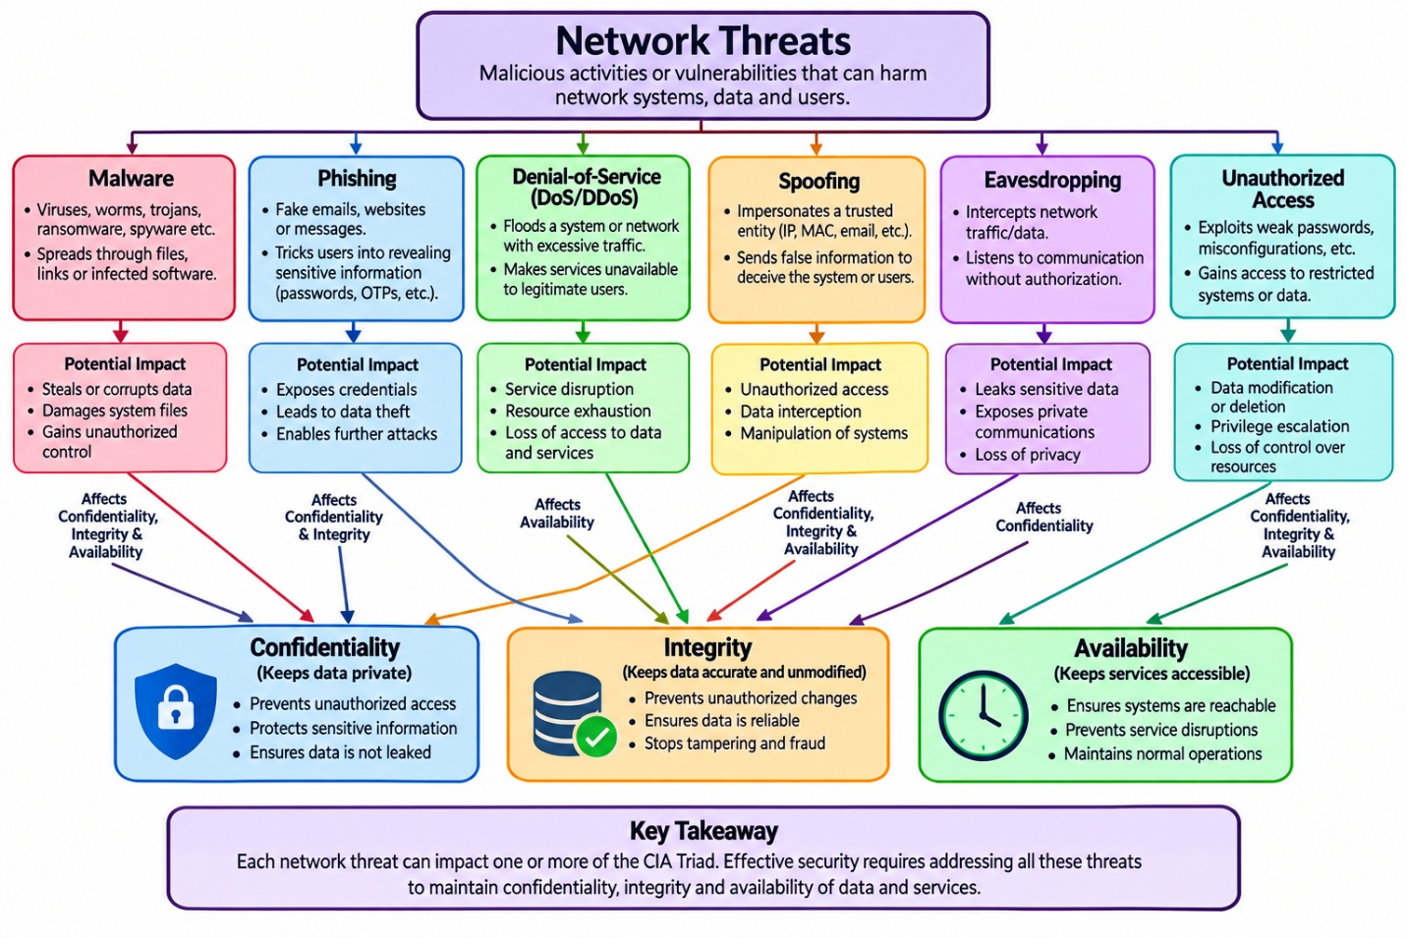

4. Develop an integrated concept map connecting Network Security Fundamentals,
Network Threats, and Threat Intelligence. Show how identifying assets, vulnerabilities,
and threats leads to the collection and analysis of threat information and ultimately
supports informed security decisions.

